PROJECT REPORT

1.INTRODUCTION

* 1. Overview

Perfume is a fragrant liquid typically made from a combination of essential oils, aroma compounds, solvents, and fixatives. It is used to add a pleasant scent to the human body, objects, or living spaces. Here's an overview of perfume, including its history, components, manufacturing process, and its role in contemporary culture:

1. **History of Perfume**: Perfume has a long and rich history, dating back thousands of years to ancient civilizations like Egypt, Mesopotamia, and India. The art of perfumery has evolved over time, with various cultures contributing to its development. Perfume was initially used for religious rituals, hygiene, and as a symbol of luxury and status.
2. **Components of Perfume**: Perfume is made up of several key components, including:
   * **Fragrance Oils (Essential Oils)**: These are natural or synthetic aromatic compounds that provide the scent. Essential oils are extracted from various sources like flowers, fruits, woods, and herbs.
   * **Solvents**: Solvents like alcohol or water are used to dilute the fragrance oils and help distribute the scent evenly.
   * **Fixatives**: These ingredients help stabilize the perfume's scent and ensure it lasts longer on the skin.
   * **Modifiers**: Modifiers are used to adjust the fragrance's intensity, longevity, and overall character.
3. **Manufacturing Process**: The creation of perfume involves several steps:
   * **Extraction of Fragrance Oils**: Essential oils are obtained through methods like distillation, cold-pressing, or solvent extraction.
   * **Blending and Formulation**: Perfumers carefully combine various fragrance oils, solvents, fixatives, and modifiers to create a unique scent profile.
   * **Aging**: The blended fragrance is left to age, allowing the ingredients to harmonize and mature.
   * **Quality Control and Bottling**: After aging, the perfume is tested for quality and then bottled in attractive containers for sale.
4. **Fragrance Types**: Perfumes come in various types with varying concentrations of fragrance oils:
   * **Eau de Parfum**: Contains a higher concentration of fragrance oils and is longer-lasting.
   * **Eau de Toilette**: Has a lower concentration of oils and is lighter in scent.
   * **Eau de Cologne**: Contains even less fragrance oil and is typically used as a refreshing spray.
   * **Perfume Oil**: A highly concentrated form of fragrance applied directly to the skin
   1. Purpose

Made from natural flower and hygienic product from affordable price.

2.Problem Definition &Design Thinking

2.1 Empathy Map

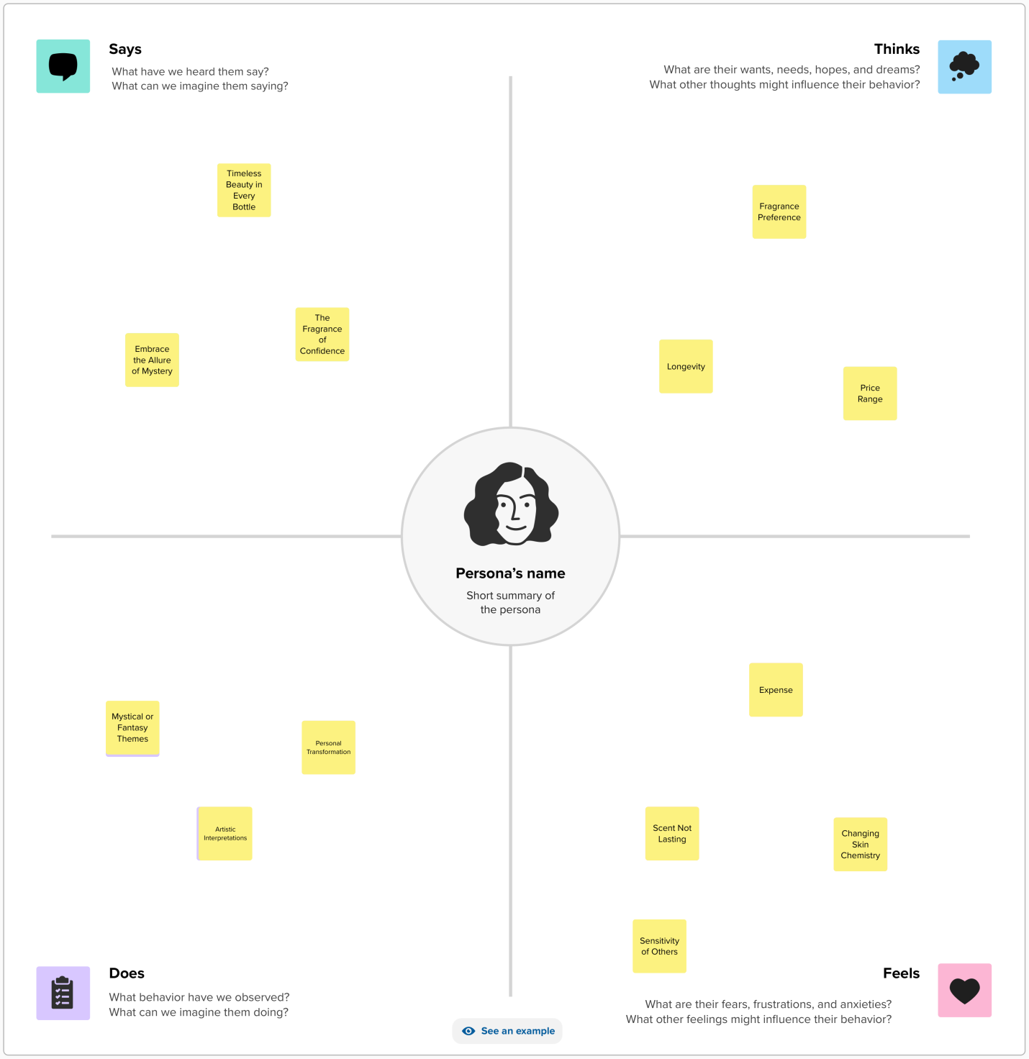

2.2 Ideation &Brainstorming Map

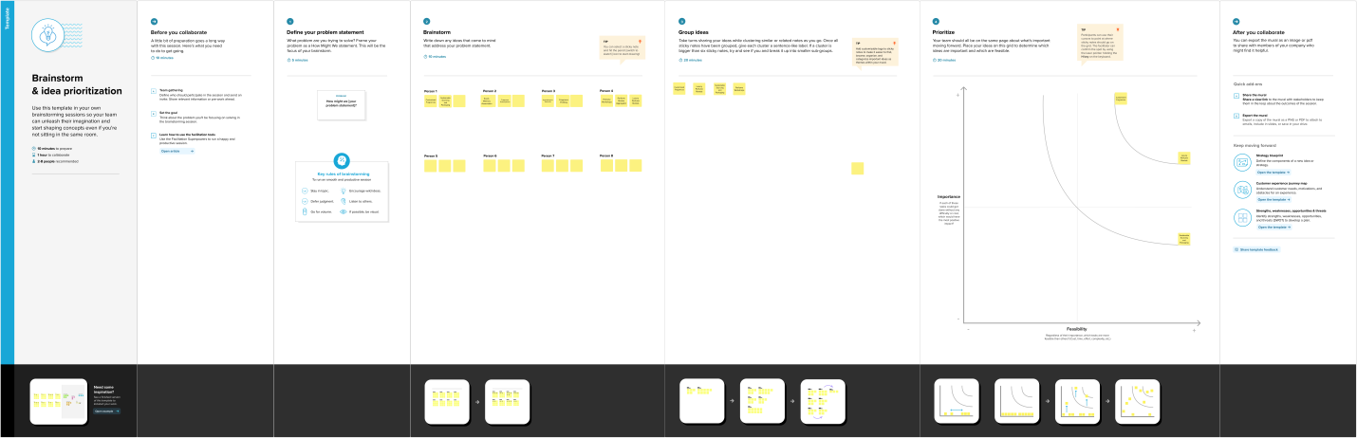

Result:

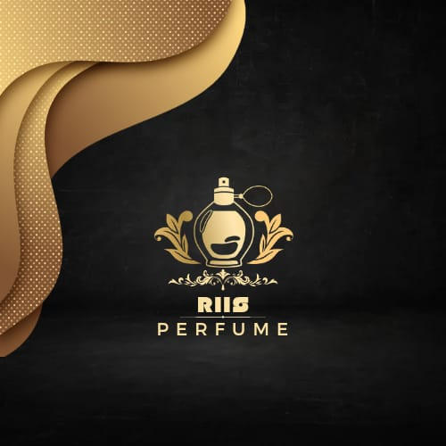

4.Advantages&Disadvntages

Advantages:

1.Affordable Price

2.Using natural product

3.Good Smell

Disadvantages:

1.Some skin allergy may occur.

5.Applications:

Perfume is primarily used for personal fragrance, but it can also be applied to clothing, linens, and even in living spaces to create a pleasant atmosphere.

6.Conclusion:

In conclusion, perfume is a fascinating and intricate fusion of art, science, culture, and personal expression. With a history spanning millennia, it has evolved from being a part of religious rituals and symbols of luxury to a vital component of personal grooming and an emblem of culture and identity.